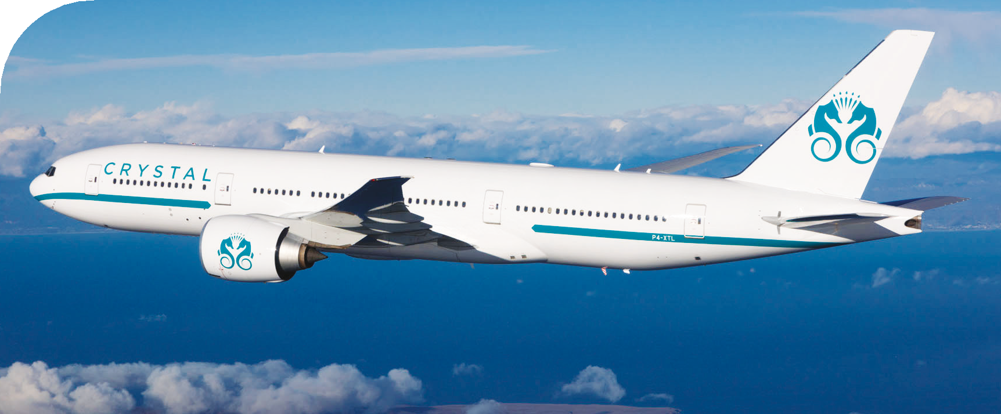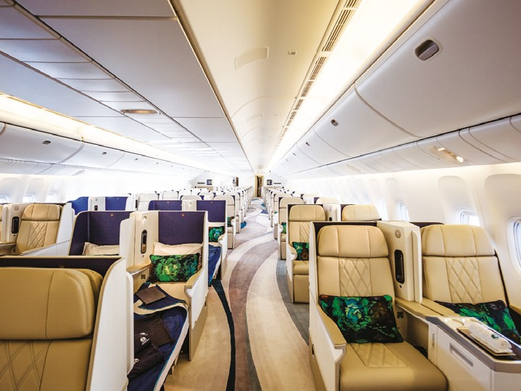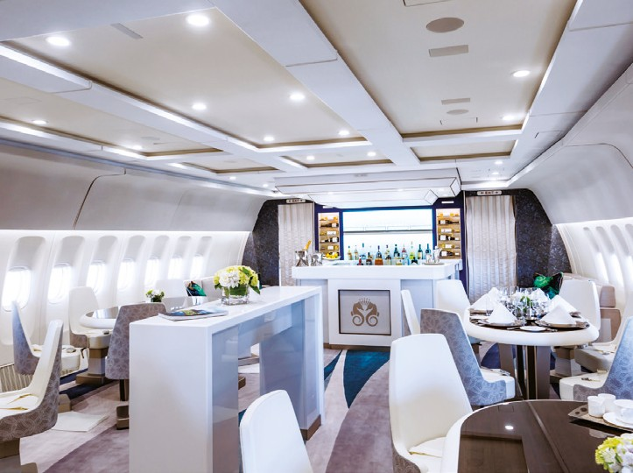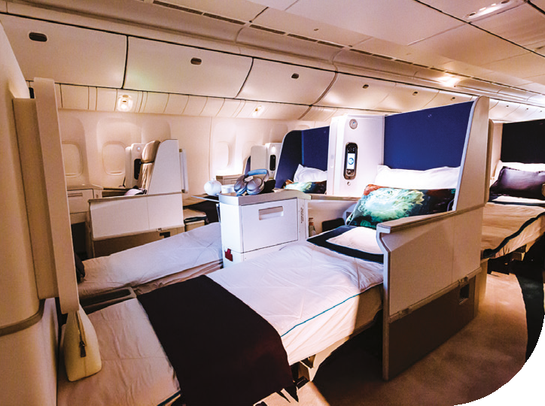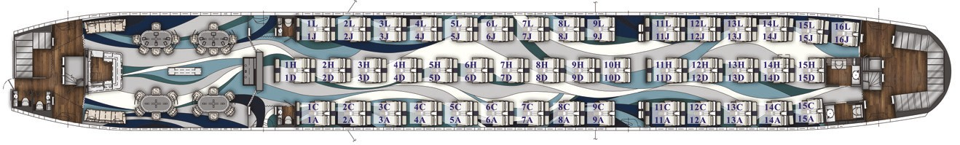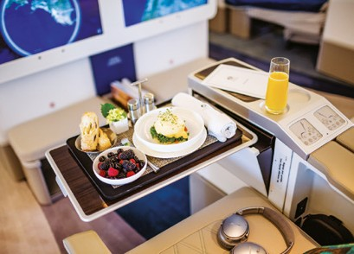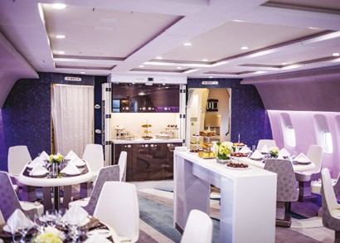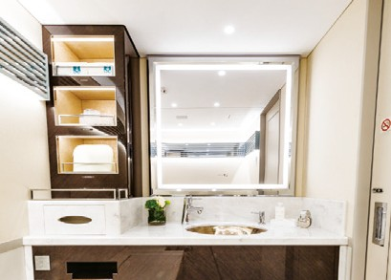

Incomparable VIP travel experience

The luxuriously designed aircraft is larger and newer than any global private jet tour travel option, appointed with features rarely found in even the most luxurious private jets. With Crystal Exclusive Class seats, for 88 discerning guests, this luxury jet is designed for maximum personal space and ergonomic comfort, and converts to 180-degree lie-flat beds. The expansive social lounge with stand-up bar and dedicated table seating fosters friendly camaraderie among luxury travelers. Cuisine will be prepared by a dedicated in flight Executive Chef, in two state-of-the-art galleys and paired with an elegant premium wine list from the Crystal SkyeCellar.

General

Registration : P4-XTL Operator : Comlux Aruba YOM : 2011 (EIS 2017) Home base : Worldwide

Capacity

Seats : 88 first class seats

Crew : 12 Sky Butlers, 3-4 Pilots,

1 Technical Engineer,

1 Executive Chef,

1 Ops Manager

Baggage : Approx. 300 standard suitcases

Performance

Range : 10,000nm

Average speed : 550 kts / 1000 km/h

Cabin Dimensions

Length : 49.10m Width : 5.86m Height : 2.20m

Inflight Entertainment System

Connectivity : WiFi, Satcom

Entertainment : 24'' touch screen video monitors, Airshow, landscape cameras, Live TV, Video on Demand, and Audio on Demand